<https://tpchd.org/healthy-places/emergency-preparedness/flooding-be-prepared/>

[Home](https://tpchd.org/) » [Healthy Places](https://tpchd.org/healthy-places/) » [Emergency Preparedness](https://tpchd.org/healthy-places/emergency-preparedness/) » **Flooding – Be Prepared**

**Flooding – Be Prepared**

**Be ready when the waters rise.**

Take a few simple steps to prevent floods around your home or business.

**Before the storm**

* Remove leaves, ice, snow and other debris away from any drains near street corners and low areas.
* Dispose fallen leaves and other yard debris in compost areas, gardens or take to the landfill.
* Direct downspouts at least 10 feet away from your home or business and clear gutters.
* If you are in a flood-prone area, keep sandbags on hand.
* Put chemicals like fertilizers, pesticides, and engine oil on high shelves.
* Is you have a septic system, keep it well maintained so that it will be prepared for the flood. Turn off power to the system and seal entry points if possible.

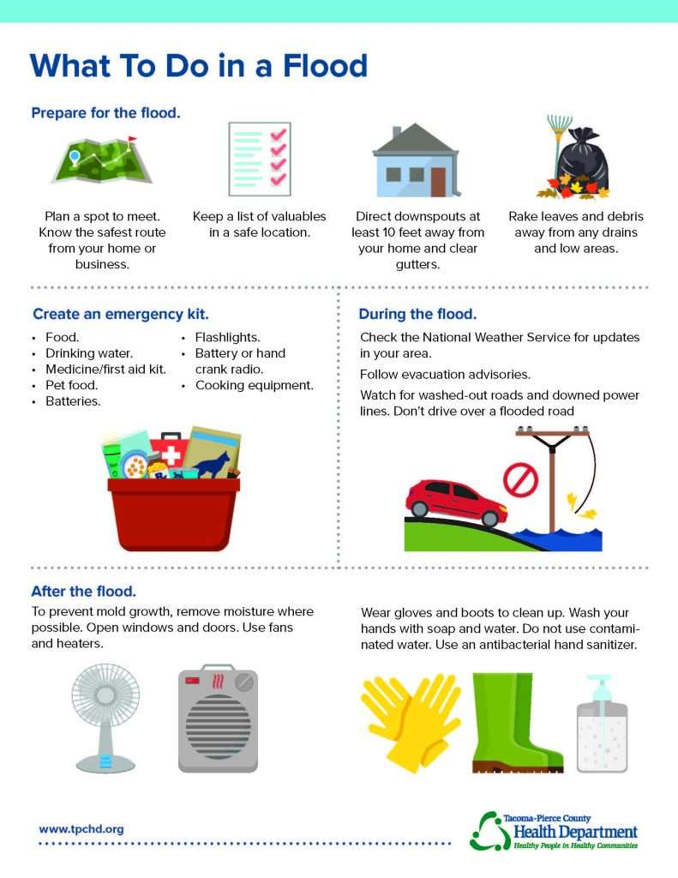

**Learn what to do before, during and after a flood.**

Available in [English](https://tpchd.org/wp-content/uploads/2023/12/What-to-Do-in-a-Flood.pdf) | [Español (Spanish)](https://tpchd.org/wp-content/uploads/2023/12/Flood-Spanish_20210301.pdf) | [Tagalog (Filipino)](https://tpchd.org/wp-content/uploads/2023/12/Flood-Tagalog_20210301.pdf) | [한국어 (Korean)](https://tpchd.org/wp-content/uploads/2023/12/Flood-Korean_20210301.pdf) | [Русский (Russian)](https://tpchd.org/wp-content/uploads/2023/12/Flood-Russian_20210301.pdf) | [繁體中文 (Chinese, Traditional)](https://tpchd.org/wp-content/uploads/2023/12/Flood-Chinese_20210301.pdf) | [Tiếng Việt (Vietnamese).](https://tpchd.org/wp-content/uploads/2023/12/Flood-Vietnamese_20210301.pdf)

**Prepare for flooding**

* Know the safest route from your home or business. Plan a spot to meet. Remember your pets.
* Keep a list of valuables, including personal property, in a safe location.
* Create an emergency kit:
  + Food.*
  + Drinking water.*
  + Medicine/first aid.*
  + Pet food.
  + Flashlights.*
  + Radio.
  + Batteries.
  + Cooking equipment.

*Keep extra in your vehicle. Ensure your vehicle has a full tank of gas.

**During the flood**

* [Check the National Weather Service](https://www.weather.gov/sew/) for updates.
* Food service establishments must close if they flood.
* Follow evacuation advisories.
* Watch for washed-out roads and downed power lines. Don’t drive over a flooded road.

**After the flood**

* [Food establishments must follow these guidelines](https://www.cdc.gov/disasters/hurricanes/pdf/flyer-eatsafefood.pdf). Contact our Food Safety Program at food@tpchd.org or (253) 649-1417 to reopen.
* To prevent mold growth, remove moisture where possible. Open windows and doors and warm the house.
* Wash your hands with soap and water. Don’t use contaminated water. Use an antibacterial hand sanitizer if soap and clean water are not available.
* Wear gloves and boots to clean up. Be sure your tetanus vaccine is up-to-date. Get a booster every 10 years.
* Discard any food items that have been in contact with flood waters.
* Clean refrigerators or freezers that had contact with contaminated water with a bleach solution (1 cup bleach per gallon of water) and wipe clean after 1 minute.

**If you get water from a well**

* Material carried by the flood can contaminate drinking water. Use bottled water or boil well water for 3 to 5 minutes before:
  + Drinking.
  + Brushing teeth.
  + Washing dishes.
  + Preparing food.
* If you can’t boil or buy water, use household bleach.
  + If the water is clear, use 8 drops per gallon of water.
  + If the water is cloudy, use 16 drops per gallon of water.
  + After adding the bleach to the water, wait 30 minutes to use.
* Flush and chlorinate your well. Use a certified laboratory to test your water for bacteria.

**If you have a septic system**

* Stay out of the area if sewage backs up.
* Don’t pump the septic tank. Pumping the tank could cause it to break, float or could damage inlet and outlet pipes.
* Don’t put water from a basement sump pump into the septic system or onto the drainfield.
* Take fewer showers or baths.
* Don’t use the washing machine or dishwasher.

**Resources**

* [City of Tacoma Flooding information](https://www.cityoftacoma.org/government/city_departments/environmentalservices/surface_water/flooding)
* [What To Do in a Flood Handout](https://tpchd.org/wp-content/uploads/2023/12/What-to-Do-in-a-Flood.pdf)
* [What to Do in a Flood if You Have a Well or Septic System Handout](https://tpchd.org/wp-content/uploads/2023/12/What-to-Do-in-a-Flood-if-You-Have-a-Well-or-Septic-System.pdf)
* [Pierce County Flood Services and Information](https://www.piercecountywa.gov/3945/Flooding)
* [EPA: “Flooding Facts”](https://www.epa.gov/indoor-air-quality-iaq/resources-flood-cleanup-and-indoor-air-quality#factsheets)
* [American Red Cross](https://www.redcross.org/get-help/how-to-prepare-for-emergencies/types-of-emergencies/flood.html)
* [National Environmental Health Association Septic Guidance](https://tpchd.org/wp-content/uploads/2023/12/NEHA-Flooding-Guidance.pdf)